**GUI DESIGN**

**Order Menu**



|  |  |
| --- | --- |
| Purpose | Showing dishes (in general and details) and allowing customers order dishes, then creating bills |
| Connect From | Menu bar |
| Connect to | Order Info |
| Validation | * **Dish on bill** * If existed, order button on that dish has no function * **Quantity each dish** * Be able to adjust up/down * Minium value: 1 * Maxium value <= available quantity * **Confirm** * Alert customers about their decisions |
| Initial values | * Dishes Info * Quantity value (minium 1) of each dish on bill * Price each dish * Value in total of bill |
| Events | * Click Order icon to add a dish on bill * Adjust quantity of each dish on bill * Click “X” on bill to remove a dish * Click Confirm to redirect to Order Info page * After each order’s succeed, quantity available laying above on each dish will reload and be updated. |

**Order Info**

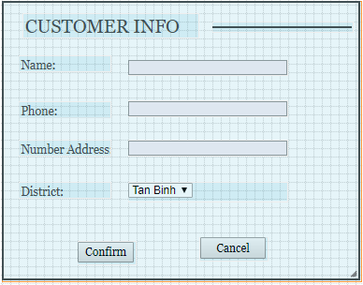

|  |  |
| --- | --- |
| Purpose | Ask more information about Order info to complete order |
| Connect From | Order menu |
| Connect to | Order succeed confirm (showing order details) |
| Validation | * **Customer name** * Not blank * 4 - 100 characters * **Phone** * Not blank * 10 – 11 characters * Format: “0XXXXXXXXX” * **Order address** * Not blank * 50 – 200 charaters * Suggestion type ahead (Street) |
| Initial values | * If it is the second booking, the customer detail shows automatically |
| Events | * Click Confirm to complete an Order |

**Order succeed confirm**

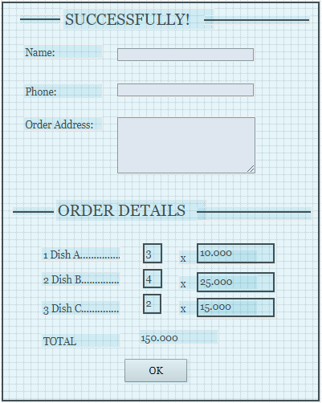

|  |  |
| --- | --- |
| Purpose | Summary orders detail and make a confirmation on order succeed |
| Connect From | Order Info |
| Connect to | Homepage |
| Validation |  |
| Initial values | * Customer info and order details |
| Events | * Click “OK” to collapse this modal |

**Order Management**



|  |  |
| --- | --- |
| Purpose | Searching Order |
| Connect From | Admin menu bar |
| Connect to | Add/Update/View an Order |
| Validation |  |
| Initial values | * Order list |
| Events | * Click Add to link to Add Order page * Click Export to pdf order list * Click Search to filter orders based on specific conditions * Click View/Edit to link to View/Edit Order page |

**Add/Update/View an Order**



|  |  |
| --- | --- |
| Purpose | Add/Update/View an Order |
| Connect From | Order Management |
| Connect to | Order Management |
| Validation | * **Customer name** * Not blank * 4 - 100 characters * **Phone** * Not blank * 10 – 11 characters * Format: “0XXXXXXXXX” * **Order address** * Not blank * 50 – 200 charaters * Suggestion type ahead (Street) * **Order ID** * Uneditable or disable * **Quantity each dish** * Be able to adjust up/down * Minium value: 1 * Maxium value <= available quantity * **Confirm** * Alert users about their decisions |
| Initial values | * If View/Edit mode, all info will display * If Add mode, Paid status is default and Complete status is default. Quantity is 1 and Dish is the first item on list. * Order ID will be generated after confirm in format “Oyymmdd”. |
| Events | * Click Export to pdf of this order (applied for complete mode) * Click X to remove a dish * Click + to add a dish * Click Confirm to complete an order * Click Remove to cancel this order |

**Dish Management**



|  |  |
| --- | --- |
| Purpose | Searching Dish |
| Connect From | Admin menu bar |
| Connect to | Add/Update/View a Dish |
| Validation |  |
| Initial values | * Draft status is default * Dish list * Monday is selected by default * First item in kind list is selected |
| Events | * Click Add to link to Add Dish page * Click Export to pdf/excel Dish list * Click Search to filter dishes based on specific conditions * Click View/Edit to link to View/Edit Dish page |

**Dish Detail**



|  |  |
| --- | --- |
| Purpose | Add/Update/View an Order |
| Connect From | Dish Management |
| Connect to | Dish Management |
| Validation | * **Dish ID** * Uneditable and disable * Generated after confirmation * **Name** * Not blank * 20 - 50 characters * **Ingredient** * Not blank * 50 – 200 charaters * **Available Quantity** * 1 – 100 unit * **Price** * 5.000 – 50.000 VND |
| Initial values | * If View/Edit mode, all info will display * If Add mode, Monday and Soup is defaul. Quantity is 1 and Dish is the first item on list. * Dish ID will be generated after confirm in format “Dyymmdd”. |
| Events | * Click Export to pdf this dish (applied for saved mode) * Click Submit to save this dish * Click Cancel to delete this dish |

**Menu Setup Management**



|  |  |
| --- | --- |
| Purpose | Searching Dish By Day |
| Connect From | Admin menu bar |
| Connect to | Add/Update/View a Menu |
| Validation |  |
| Initial values | * Dish list by Day |
| Events | * Click Add to link to Add Menu page * Click Export to pdf Menu setup list * Click Search to filter orders based on specific conditions * Click View/Edit to link to View/Edit Menu setup page |

**Menu Setup Detail**



|  |  |
| --- | --- |
| Purpose | Add/Update/View Menu setup |
| Connect From | Menu setup list |
| Connect to | Menu setup list |
| Validation |  |
| Initial values |  |
| Events | * Click Submit to save this setup * Click Cancel to delete this setup |